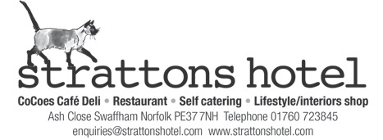

Covid 19 Dinner Guest Information
Please be assured we have a comprehensive list of measures including staff training that we have put in place since reopening on 4th July 2020.
These guidelines and regulations will be under constant review as we follow government and UK Hospitality recommendations.
We request that should you be displaying any symptoms of Covid-19 that you call us to postpone your visit with us. These include a new persistent cough, high temperature or loss of smell and taste.
Dinner:
Dinner will be available in CoCoes as a service pre-booked between 5pm and 8pm daily. A menu is available on our website or by e-mail. If you have booked a table in CoCoes please do not arrive early or late as you may not be seated. All dinner menus will be presented on a single use paper format to you. Hand sanitisers will be provided at the entrance to CoCoes to use prior to entry.
Afternoon tea:
Afternoon tea is available daily, pre booked and can be served as take away, in the hotel lounges, restaurant or outside. Bookings must be made with at least 72 hours notice. If you have booked a sit in option please do not arrive early or late as you may not be seated. Hand sanitisers will be provided at the entrance to the hotel to use prior to entry.
Our Team:
Please be assured that every member of our team has undergone full training on how to prevent the spread of Covid-19 within the hotel setting.
Any team member displaying symptoms or who has been contacted by NHS track and trace will be immediately sent home and required to self-isolate for 14 days prior to returning to work.
All team members are temperature checked upon arrival at work and will be required to confirm that they have not been in contact with anyone with Covid 19 symptoms.
Team members are provided with PPE relevant to their area of work and have been given full training on how to use this correctly. All our staff have access to hand sanitiser, soap and paper towels and are trained in using these products and procedure’s thoroughly and regularly.
It is not mandatory for restaurant or kitchen staff to wear masks. We are heavily regulated and inspected by the local district council EHO department. We ask you to take your responsibility visiting us seriously
